***Sagar Institute of Science & Technology (SISTec), Bhopal***

## *Department of* *COMPUTER SCIENCE & ENGINEERING*

***Bhopal (M.P.)***

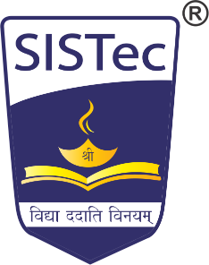

***June-2023***

# *CERTIFICATE*

I hereby certify that the work which is being presented in the B.Tech. Major Project-I Report entitled **Design And Development of Event Management System,** in partial fulfillment of the requirements for the award of the degree of ***Bachelor of Technology*** in ***Computer Science & Engineering*** and submitted to the Department of Computer Science & Engineering, *Sagar Institute of Science & Technology (SISTec)****,*** Bhopal (M.P.) is an authentic record of my own work carried out during the period from Jan-2023 to June-2023 under the supervision of **Prof. Jai Mungi**.

The content presented in this project has not been submitted by me for the award of any other degree elsewhere.

|  |  |  |  |
| --- | --- | --- | --- |
| *Signature* | *Signature* | *Signature* | *Signature* |
| **Ankit Vishwakarma**  **0187CS191028** | **Divyanshi Pandey**  **0187CS191049** | **Geetanjali Kushwaha**  **0187CS191054** | **Harsh Khare**  **0187CS191060** |

This is to certify that the above statement made by the candidate is correct to the best of my knowledge.

***Date:***

|  |  |  |
| --- | --- | --- |
| **Prof. Jai Mungi** | **Prof. Rahul Dubey** | **Dr. Keshavendra Chaudhary** |
| **Project Guide** | **HOD** | **Principal** |